Submit screenshots of the results, code files, and a writeup describing your algorithm and the results, in a zip file.

**Figure 1.** Recursive algorithm implemented in C++ determining whether a string is a palindrome.

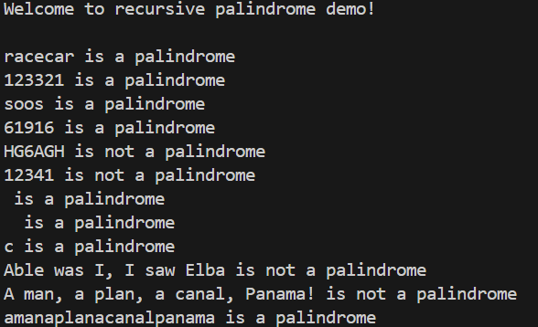

**Figure 2.** Results of recursive algorithm implemented in C++ on various input strings.

The algorithm uses a simple two pointer approach on a string input to determine whether the string is a palindrome. The algorithm accepts a string input and two pointers representing the extreme left and right character indices. So long as the left and right pointers are not equivalent, a comparison on these character indices is made. If the characters are not equivalent, then the algorithm terminates. Otherwise, the left and right pointers are incremented and decremented, respectively.

The algorithm returns false for string inputs containing non-alphanumeric characters which are asymmetrically distributed about the center of the string. In addition, it considers an uppercase letter inequivalent to its lowercase variant. This can be rectified by modifying a copy of the string prior to executing the algorithm if alternative behavior is desired.

The algorithm requires at worst $\frac{n}{2}$ comparisons of characters in the input string. Hence, the time complexity is linear. The space complexity is constant.